**Ideation Phase**

**Empathize & Discover**

|  |  |
| --- | --- |
| Date | 27 June 2025 |
| Team ID | LTVIP2025TMID29301 |
| Project Name | Citizen AI – Intelligent Citizen Engagement Platform using IBM Granite |
| Maximum Marks | 4 Marks |

**Empathy Map Canvas**

An empathy map is a simple, easy-to-digest visual that captures knowledge about a user’s behaviours and attitudes.

It is a useful tool to helps teams better understand their users.

Creating an effective solution requires understanding the true problem and the person who is experiencing it. The exercise of creating the map helps participants consider things from the user’s perspective along with his or her goals and challenges.

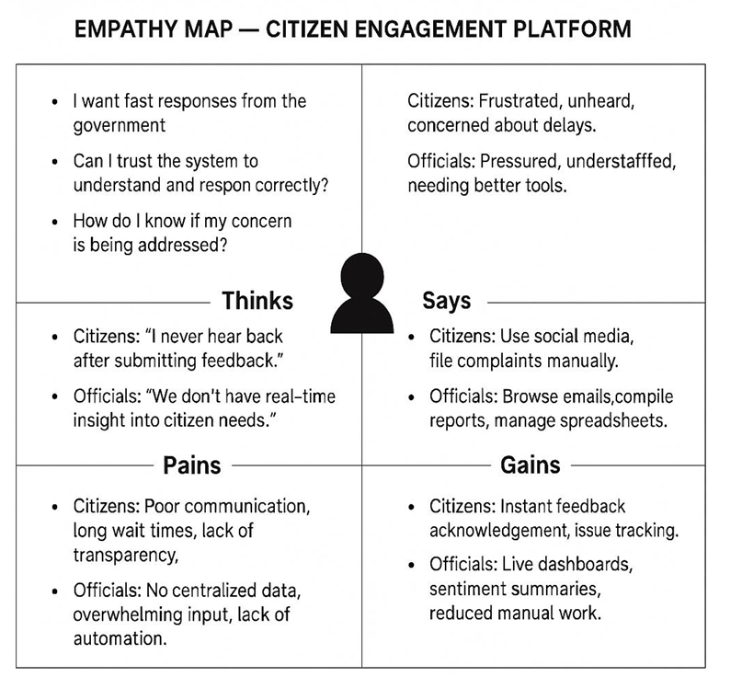

| **Thinks** | **Feels** |
| --- | --- |
| - "How can I report civic issues quickly and get real-time updates?" - "How do I make my city safer, greener, and more efficient?" - "Can smart systems actually improve my daily experience?" | - **Citizens**: Frustrated by delays, concerned about traffic, pollution, safety. - **Admins**: Overloaded with data, public pressure, resource constraints. |
| **Says** | **Does** |
| - **Citizens**: "I don’t know who to contact when something goes wrong." "I wish there was a simpler way to give feedback." - **Admins**: "We need data-driven tools to act faster." "Smart infrastructure should reduce our workload." | - **Citizens**: Use public transport, report issues, search for services, engage on social media. - **Admins**: Monitor dashboards, analyze data, manage city services. |

| **Pains** | **Gains** |
| --- | --- |
| - **Citizens**: Unclear reporting, slow resolutions, lack of transparency. - **Admins**: Disconnected data, manual processes, reactive responses. | - **Citizens**: Centralized smart city app, real-time alerts, voice/chat support, personalized tips. - **Admins**: Unified dashboards, AI/ML insights, predictive maintenance, better engagement metrics. |